Happy Work-iversary!
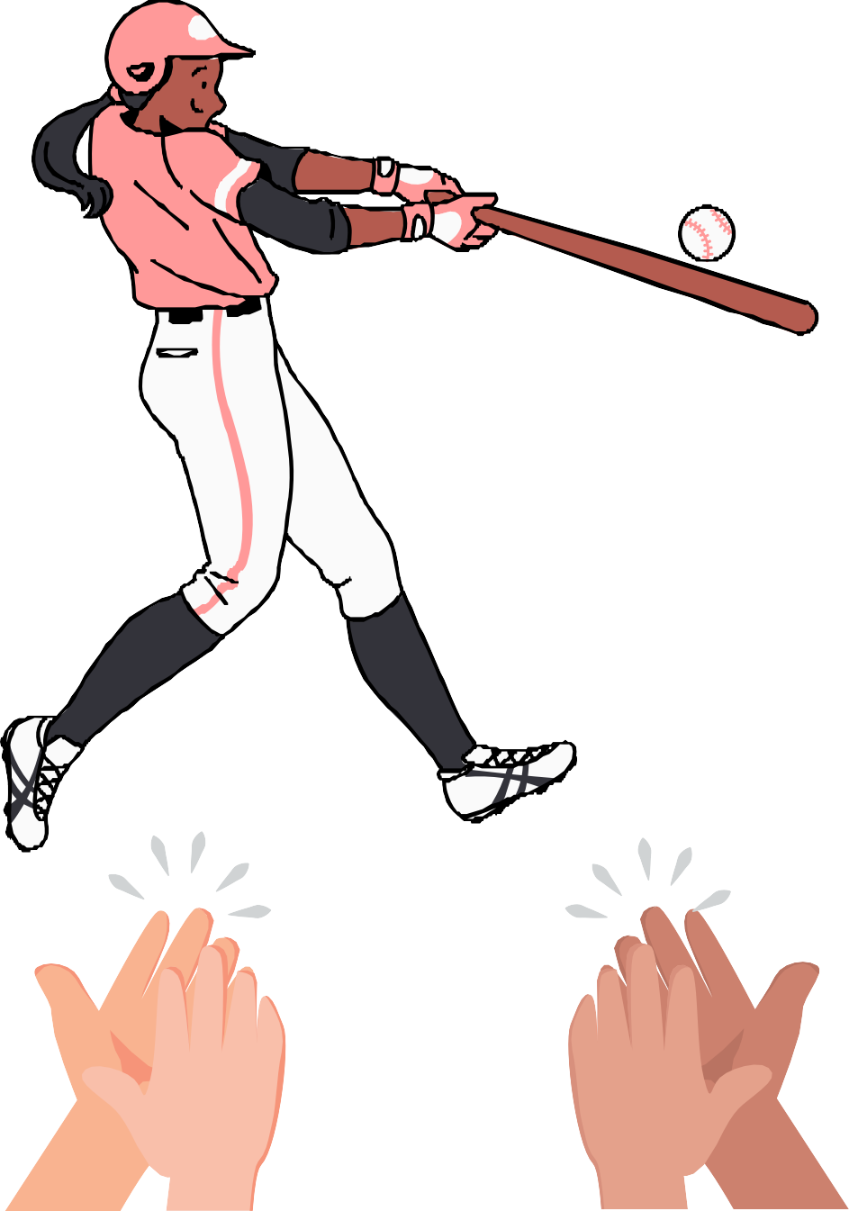
You've been scoring goals in the workplace for years. Keep hitting those career home runs!

