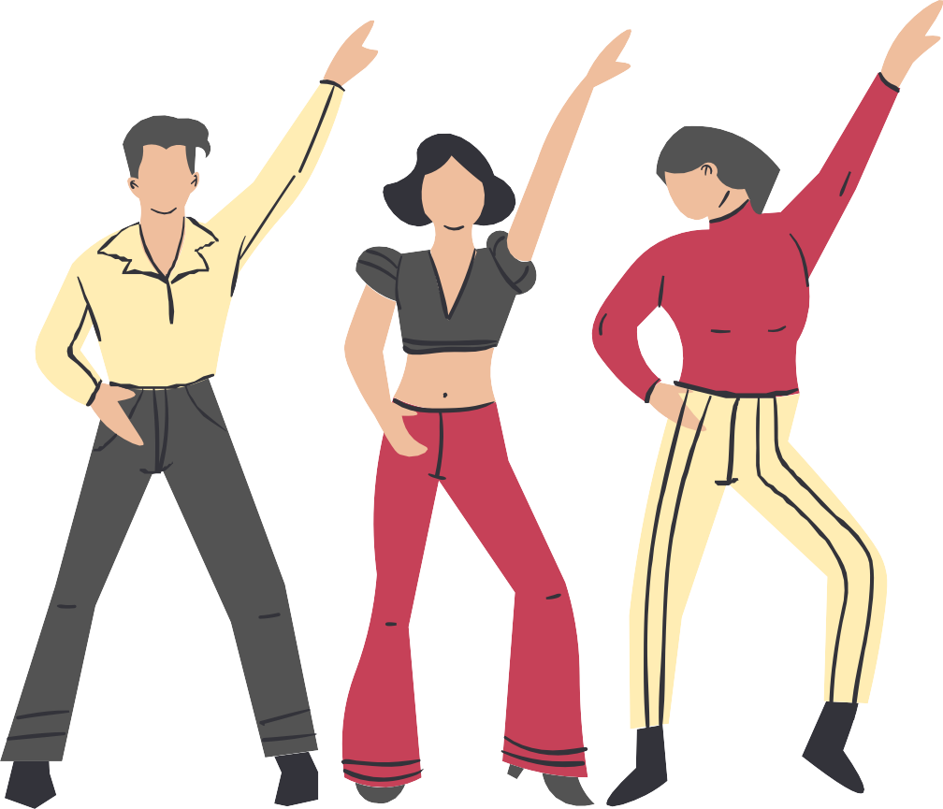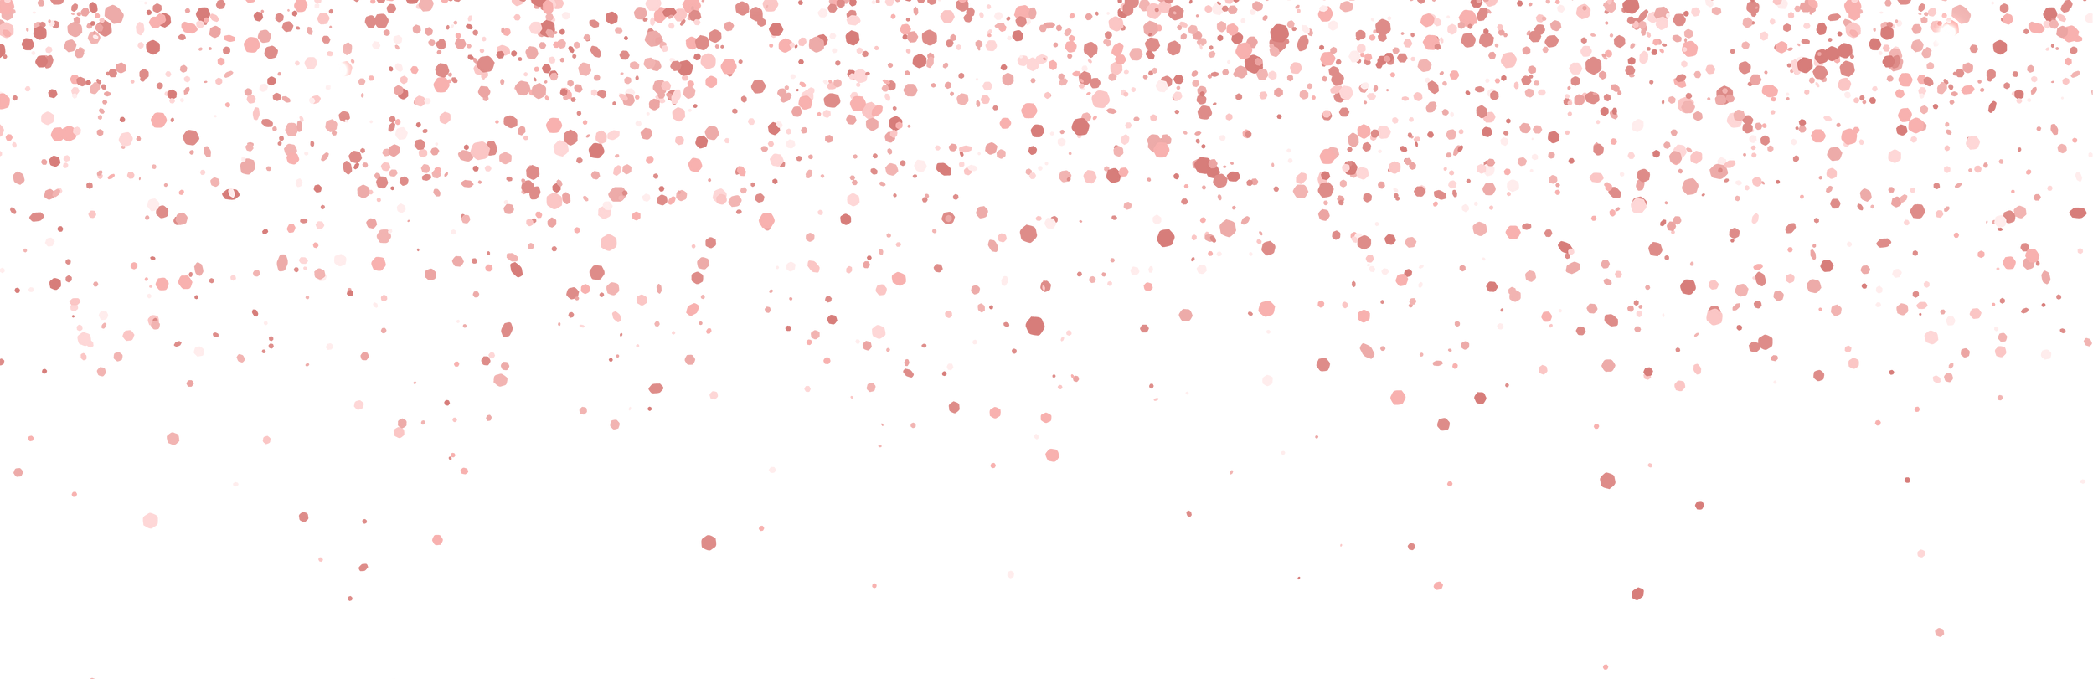Happy Work Anniversary!

Working with you feels like a dance! Each day is a new step in our shared journey, filled with joy and collaboration.

