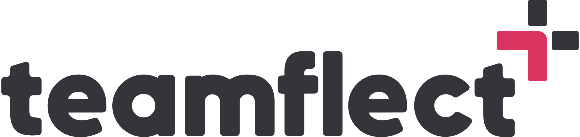 Employee Development Plan Templates

-CAREER DEVELOPMENT PLAN-

Name:
Current Position:
Date:

Self-Assessment:
Skills and Strengths: [Templates may change but self-assessments are still extremely important. Identify existing skills and strengths as well as gaps in them.]
Interests and Passions: [Reflect on your interests, passions, and what motivates you in your career. What makes you get out of bed with a smile?]

Career Exploration:
This section is rather self-explanatory. Explore the directions you may wish to take your career in. Two of the best ways to do that are:
- Research and Information Gathering
- Networking:

Setting Career Goals:
Long-Term Vision: [Dare we say, "Where do you see yourself in 10 years?"]
Short-Term Objectives: [Don't lose sight of the present when mapping out the future. Make sure you focus on short term goals and objectives as well.]

Skill Development:
Identify Key Skills: [What are the skills you will be needing now that you've set goals for yourself?]
Skill Gap Analysis: [Compare the skillset highlighted in the first section with the skills identified above.]
Training and Development: [Find and enroll in training programs, workshops, online courses, or certifications to acquire new skills or enhance existing ones.]

Progress Check-ins
The most important part of a development plan is checking in every once in a while to make sure you are on track. Some ways to do that in this scenario are:
- Performance Metrics: [Establish key performance metrics in order to measure the success of your ongoing career development process.]
- Feedback: [Seek feedback from supervisors, peers, and mentors to gain insights into your strengths and areas for improvement.]

