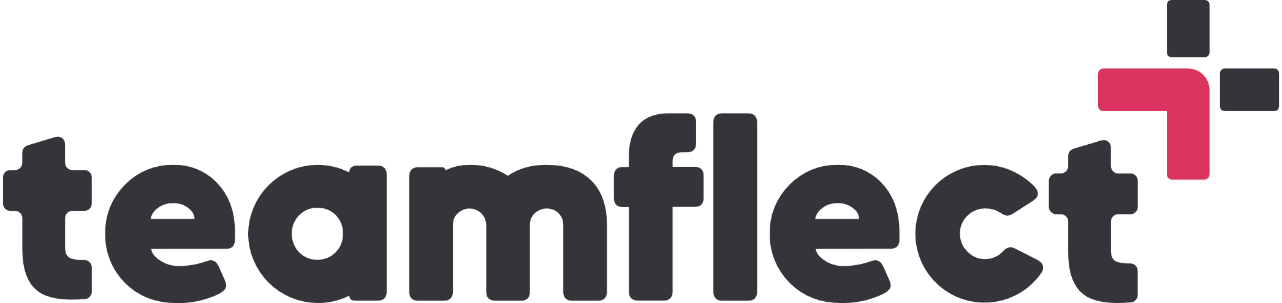 Employee Development Plan Templates

-EMPLOYEE DEVELOPMENT PLAN TEMPLATE-

Employee Name:
Position:
Department:
Date:

- Competencies and Goals
Question 1: What are your primary career goals and objectives?
Question 2: What are your strengths and areas for improvement?
Question 3: What are your short-term and long-term career objectives?
Question 4: What specific skills or competencies do you need to develop to advance in your career?
Question 5: How do you plan to measure your progress towards achieving these goals?

- Action Plan
Question 1: What are the actionable steps you will take to achieve your development goals?
Question 2: When do you plan to complete each step, and who will be responsible for their completion?

- Progress Tracking and Evaluation
Question 1: How will you measure your progress towards achieving your development goals?
Question 2: How often will you review your progress, and who will be involved in these reviews?

