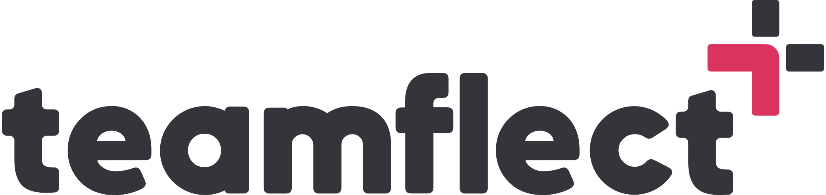 Employee Development Plan Templates

-INDIVIDUAL EMPLOYEE DEVELOPMENT PLAN-

Employee Name:
Position:
Department:
Date:
Current Skills and Competencies Assessment:
- Where does the employee stand currently? Conduct a comprehensive evaluation of the employee's current skills, knowledge, and competencies.
- Review performance evaluations, feedback, and any available data. This is a great time to check the data your performance review software has stored for you.
- Identify strengths and areas for improvement.

Development Goals:
- Collaborate with the employee to define specific, achievable, and most importantly, time-bound development goals. (You might want to take a look at our goal setting templates as well).
- Align goals with the employee's career aspirations, departmental objectives, and organizational needs.
- Ensure that goals are challenging yet realistic.

Development Strategies:
- Consider various learning methods. Remember, everyone learns at their own pace. Each employee responds better to different methods such as training programs, workshops, mentoring, job shadowing, online courses, or conferences.
- Nothing helps growth like a good hard challenge. Make sure you include a stretch assignment in this section.
Progress Tracking and Evaluation:
Set regular checkpoints to monitor the employee's progress toward their development goals.
- Provide constructive feedback and recognition to motivate the employee and ensure continuous improvement.
- Evaluate the effectiveness of the development plan periodically and make necessary adjustments as needed.

